The document layout will be 11pt font size, single line spacing (1.0), with normal margins (default in MS Word of 2.54cm all round).
Please do not deviate from the document layout - it is the same for all - this will result in approximately 750 words per page.
You can write up to one page for each essay and one page for the data question (all 4 parts a to d) - this will result in 3 main pages of text and approximately 2250 words.
If the writing for one question exceeds 1 page this is OK providing the overall page count does not exceed 3 main pages of text.
You can include in-text citations in APA format - these will contribute to the word count/page count.
You should include a reference list in APA format of up to one page - this will not be included in the word count/page count.
Most people should therefore be submitting a 4 page document as illustrated below.

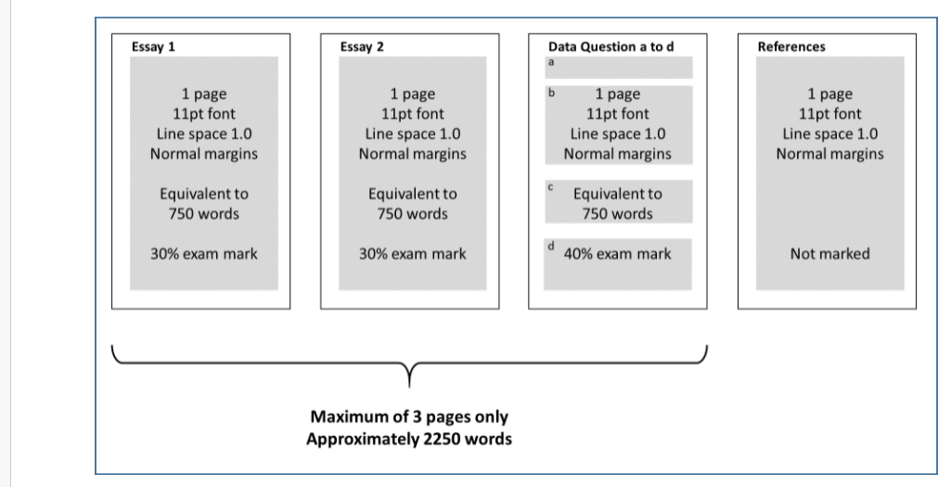

Essay questions answer 2 out of 6 (30% of exam per essay)
Guideline time 36min per essay
Here I will choose two questions and send it to you.

1) The current climate change agenda is advocating the need to move toward more plant-based nutrition. What are the implications here for sport and the performance nutrition interventions associated with it?

Lower quality protein, low in one or more amino acids, reduced digestibility are all potential issues; in theory there is a problem but little evidence that athletes cannot achieve adequate protein via a vegetarian diet which is properly planned
Some students may mention benefits for some athletes of milk-based and/or whey-based drinks and supplements and that this advantage may be less accessible
Not covered in teaching but students may flag the bioavailability of iron in plant sources as an issue – more likely to affect female athletes
Creatine availability in meat is an issue which may affect some athletes. Perhaps there will be increased reliance on supplements?

2) An American-based website (www.uphillathlete.com) publishes training and nutrition guidance for Alpine climbers and high-altitude mountaineering expeditions. One of their recent publications advocated fat adaptation and summarised the following;
“…fat adaptation DOES enhance endurance performance, it’s simple to implement, top coaches and athletes have known about this for decades and it has recently become well understood by science…”

From a scientific and sport nutrition perspective what do you think of these conclusions in the context of the intended audience?

• Current evidence on performance in endurance efforts is contradictory – metabolic effects but often no functional transfer. Some data show reduced economy which can damage performance. So an emphatic ‘DOES’ seems inappropriate. For climbers and mountaineers may move slower than endurance athletes and some anecdotal evidence from arctic explorers suggests benefits that can help management of food availability.
• protocols are fairly disruptive and occur over a number of days - not that simple
• students can write here about ‘levels of evidence’ (anecdotal level) and generalisability (athletes to climbers)
• the mechanisms are better understood but there is endless controversy (‘nail in the coffin’ papers etc)

3) Please answer both parts of this question about carbohydrate and fluid intake:
a) Describe an appropriate carbohydrate AND fluid intake strategy for time-trial exercise lasting 30-75 min AND for time-trial exercise lasting 2-4 hours. (30%)
b) Referring to current literature on carbohydrate and fluid intake, justify each strategy and compare and contrast the two strategies. (70%)

• Introduction should refer to recent updates to carbohydrate intake recommendations. Similarly, debate is ongoing regarding the appropriateness of fluid intake strategies that seek to minimise body mass loss during exercise. As a result, fluid intake strategies can be discussed separately or alongside the carbohydrate specific information.
• The 30-75 min TT discussion should include a justified strategy for carbohydrate intake during exercise of this duration. Reference should be made to the key features of the carbohydrate intake guidelines for exercise of this duration. There should be a discussion of the importance (or lack) of carbohydrate ingestion during exercise of this duration, and the research investigating carbohydrate mouth rinsing.
• The 2-4 hour TT discussion should include a justified strategy for carbohydrate intake during exercise of this duration. Reference should be made to the key features of the carbohydrate intake guidelines for exercise of this duration. In particular, the increasing carbohydrate intake rate and the potential role of multiple transportable carbohydrates should be highlighted.
• Either within the above two sections, or as a separate section, the differences in the presented carbohydrate intake strategies should be justified. This should be done by explaining the evidence behind the new carbohydrate intake guidelines, and by referring to current knowledge on the proposed mechanisms of carbohydrate efficacy during different exercise durations.
• As part of the answer, the fluid intake strategy for each exercise duration should be discussed. This should include a discussion of the historical perspective that body mass loss ≥2% should be avoided, and the more contemporary view that drinking to thirst strategies may be more effective. Key arguments in the literature against the 2% body mass threshold should be discussed, and some of the primary and review literature discussed in class should be used to emphasise the more contemporary view. With this information, the student should be able to justify their chosen fluid intake strategies.

4) Body composition is assessed routinely in a number of sports in a variety of ways. Identify why body composition measurement is important for a sport and population of your choice. Identify the method of measurement you would choose to assess body composition; the outcome measures you would report and how these data might be used. Explain your rationale for these decisions.

Students should demonstrate an awareness of the value of body composition beyond assessment simply for the value of profiling. They might explain a need to review and plan nutrition and training programmes, explore associations between body composition and performance to review ‘optimum’ body composition for performance, and explore changes in body composition in their sport over time, and the impact this may have had on player well-being (injury and extreme practices). Students will be rewarded for noting the value of understanding body composition beyond expression of percentage body fat and fat free mass and consider the use of additional outcome measures to review athlete and sport profiling (e.g. muscle circumference, segmental body composition, bone density). Students should choose a method for assessing body composition and provide a rationale for the choice. Students may provide a critique of alternatives to strengthen the rationale. The student should indicate frequency of assessment and how they will feed this into the athlete support.

5) The timing of nutrition for exercise has often been debated; these days the term periodization of nutrition is increasingly heard. What is the difference, if any, between the timing and periodization of nutrition and what are the key issues for sport nutrition and for athletes?

Pre- during- post-exercise concepts; examples connected to CHO, PRO, fluid, some supplements such as caffeine. These are nutrition timing issues which can offer acute effects.
Periodization: Periodized nutrition refers to the strategic combined use of exercise training and nutrition, or nutrition only, with the overall aim to obtain adaptations that support exercise performance. Various examples connected to Jeukendrup 2017 can be discussed including train low approaches etc. Periodized nutrition relates to adaptation and chronic effects.

6) Exercise professionals may be involved in application and dissemination of information relating to sport nutrition; this can be problematic. Some circumstances in particular require sensitivity and involve potential risks to both athlete and exercise professional if not handled correctly. Identify some of these problematic areas discussing any risks, obligations and the limits to practice for exercise professionals?

• Answers to include any of areas below – more the better
• Body composition measurement: students might recognize the risks in assessing body composition in athletes that are suffering from, or are at risk of, RED-S. They should explain educational support they might offer when taking body composition assessments. They should stress the requirement for sensitivity, and the focus on the assessment for monitoring concerning changes rather than absolute value. Use of DEXA might be stressed as best approach, as should low frequency of assessments and focus on muscle mass rather than body fat.
• Individualised advice issues; British Nutrition Association guide on limits to practice for exercise professionals
• Supplement recommendations
• Eating disorders material
• Children & adolescents

Data Interpretation 40% of exam paper
Answer all parts (a to d; weighted equally) Guideline time 48min

The U.S. armed forces are concerned the dietary intake of military trainees may be inadequate due to the structured food environment, lack of snacking, and limited time for meals. This could increase risk of injury and reduce performance causing attrition of recruits from military training.

In a pragmatic study U.S. Air Force trainees in two separate squadrons received either a snack bar to eat before bed (snack squadron n = 423) or no intervention (standard squadron n = 444) during the first 4 weeks of a total of 8 weeks basic military training (Bartlett & Stankorb 2017). Various indices of fitness are routinely recorded to determine whether recruits pass/fail their fitness test. These data were used as outcome measures in this study to examine the effect of the intervention (Figure 1). During the 4 weeks the standard squadron became aware of the snack bars and requested them. Consequently, both groups received bars for the final 4 weeks of training; there were no group differences in any data after 8 weeks of training.

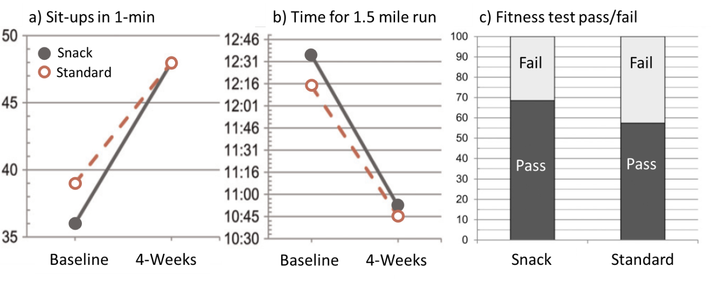
Figure 1. Change in two physical fitness measures during 4-weeks of initial military training (a and b) and the percentage of recruits passing or failing their fitness test after 4-weeks (c). Recruits received a daily nutrition bar (‘Snack’ squadron) or no intervention (‘Standard’ squadron). The group differences in change scores (a and b) and proportions (c) were all statistically significant (p<0.001).

Questions
a) Based on the methodology of this study explain any experimental design concerns which could bias the data and findings.
Appears there are two discrete cohorts and therefore not randomised, at least at individual level. There is no placebo or attention control and therefore no blinding. The tests are voluntary and maximal and therefore vulnerable. There are also clear cross-contamination issues as the control group were aware of something potentially beneficial Better students will align critique to CASP critical appraisal approach used in class
b) What can you conclude from the results; interpret the data as far as you can?
Training effects visible in both fitness outcome in BOTH groups. Greater gain in snack group; however differing baselines. Although change is significant the end 4-wk results are very similar. Pass rate still seems sensitive to a difference – criteria not described in paper. The 8week data are potentially biased but do support possible benefits. Better students will align critique to CASP critical appraisal approach used in class. In terms of mechanism any CHO/PRO/supplement content could be beneficial from both an acute and adaptation perspective but ingredients unknown.
c) The composition of the nutrition bar is currently classified by the U.S. armed forces. If you were designing a snack bar for them to issue before bed, explain the ingredients you would include in it and what guidance, if any, would you give about its use?
Since overall nutrition is restricted then nutrient density is key. This should contain CHO and protein. Pre-sleep casein could be mentioned and PRO around 40g would align to current thinking. Micronutrient content (vitamin D etc) would be of value. The advice should be that the bar should definitely be consumed prior to sleep.
d) Describe the kinds of research you would do to examine concerns the U.S. armed forces have raised about dietary intake among their recruits?
The U.S. armed forces are concerned the dietary intake of military trainees may be inadequate due to the structured food environment, lack of snacking, and limited time for meals. This could increase risk of injury and reduce performance causing attrition of recruits from military training. Observational, longitudinal research recording 3-d dietary intake of recruits alongside simple anthropometry (body mass) and estimates of daily energy expenditure. Energy balance and nitrogen balance could be informative to identify whether diet is inadequate. Macronutrients could be compared to for instance ACSM guideline for nutrition and sport. Other research could involve simple interventions (proper RCTs with participants in different locations) such as changes to snacking, mealtimes and food infrastructure to see if this influences dietary intake. One could also measure the outcomes of injury incidence, fitness and dropouts/attrition.

